QShopping

Taimoor Hussain (201904453)

Abrar Shahriyar Hossain (201912955)

Ahmed Ashraf Abdou (202005605)

Omer Ahmed (201904193)

Skander Charni (201908360)

Contents

Motivation 2

Initial GUI Design 3

Final Implemented Design 4

Database Design 5

Design and Architectural Patterns 6

Implementation 7

Additional Features 8

New Gained Knowledge and Skills 9

Reflections 10

Resources 11

Appendix A: Json Files 12

# Motivation

This project seeks to connect store owners to customers through a convenient and easy to use interface: An android app that lets customers browser and order products, and lets store owners list their products and keep track of orders. This is an important issue especially in the post-pandemic time when many stores have closed due to the lack of customers. Offering an online marketplace will enable stores to expand their reach and thus increase profits while also benefiting customers by allowing them to order goods from the comfort of their own home and widening the range of stores that are available to them.

# Initial GUI Design

The design of our app was created with Figma. The design was influenced by a number of Figma templates as well as already published shopping apps on the Google Play Store. We created the app's logo and selected the color palette we believed best suited the idea behind the app.

Figma is an online tool for designing user interfaces and altering visuals. It may be used for a variety of graphic design tasks, including wireframing, creating user interfaces for mobile applications and creating high fidelity design prototypes. Figma can operate directly in the browser without the need to install any other software, which is another advantage of utilizing it. Moreover, Figma enables team collaboration on a single design template, which allowed our team to communicate with the design in real time without having to physically meet. We were given free access to all of its features, which are usually paid, because we had student accounts.

Our design is based on various current UI/UX practices. When the user first runs the app, they shouldn't anticipate being inundated with a lot of colors and animations with crowded elements, thus we first chose to keep the design simple. This may be determined by examining the layout and process of a user's registration and login, as the design is simple and requests data in accordance with its intended usage. Using icons on buttons, most of the features were designed to be self-explanatory and easy to navigate through. Fewer colors were used in the theme and the app's typography was maintained throughout. We thought of having notifications implemented and gestures to let the users have an intuitive interaction with the app; However, due to restricted timeline for the project, we decided not to add them in the design.

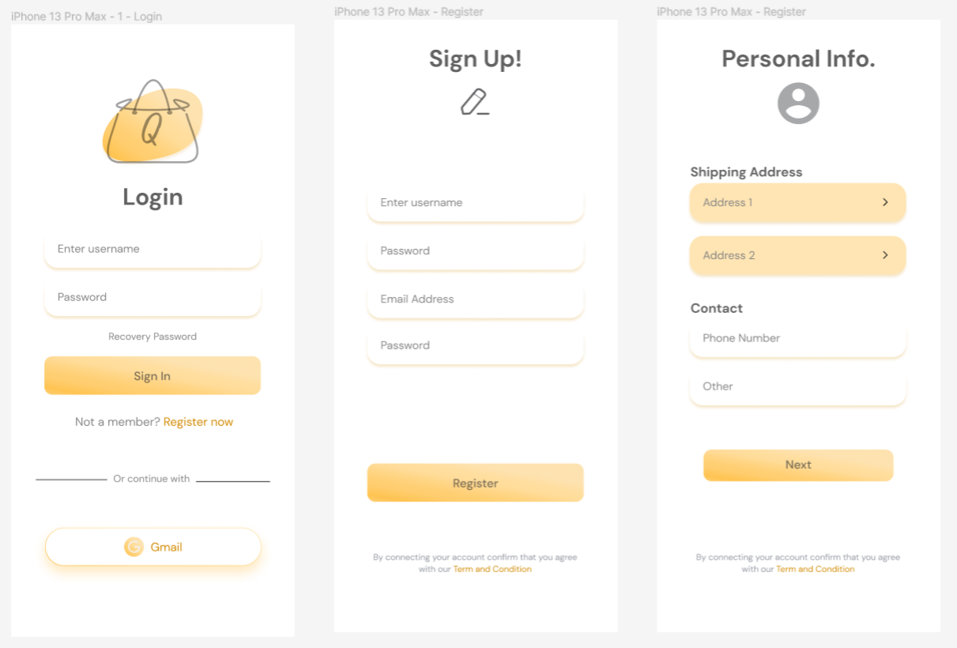

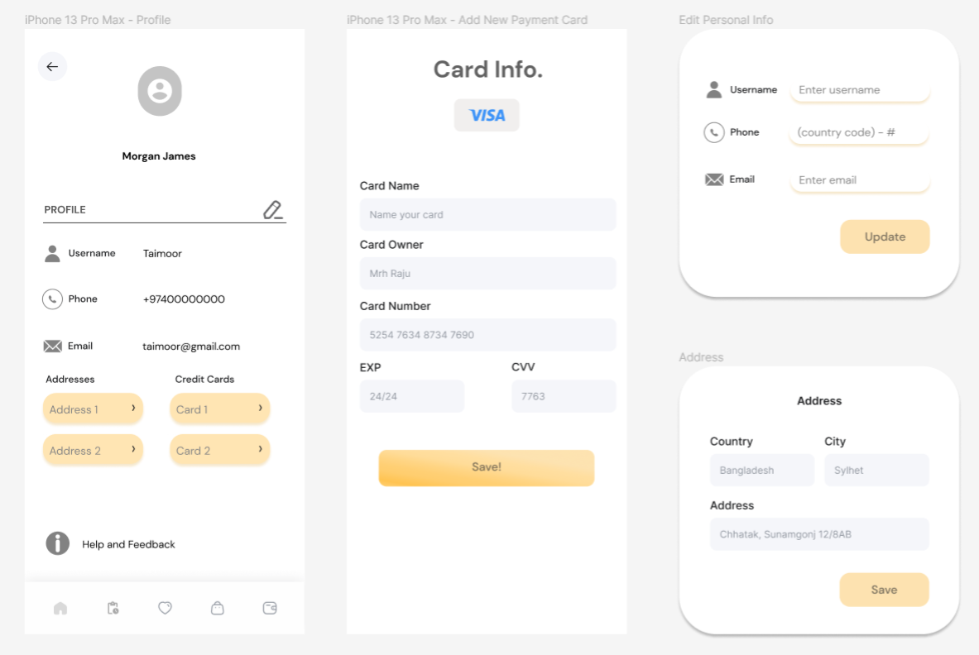

Home Screen (Admin and User) and Category Screen

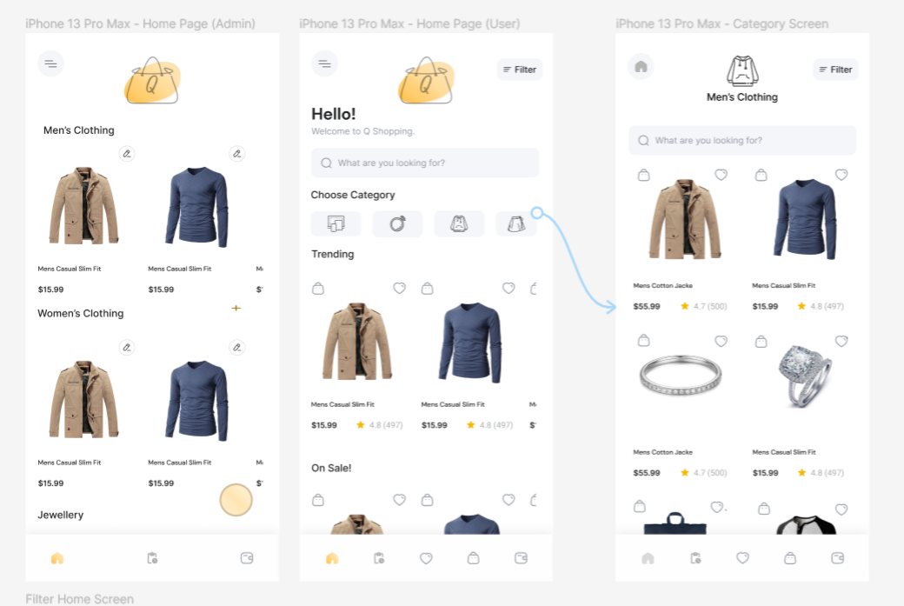

Admin Dashboard and Report Screens

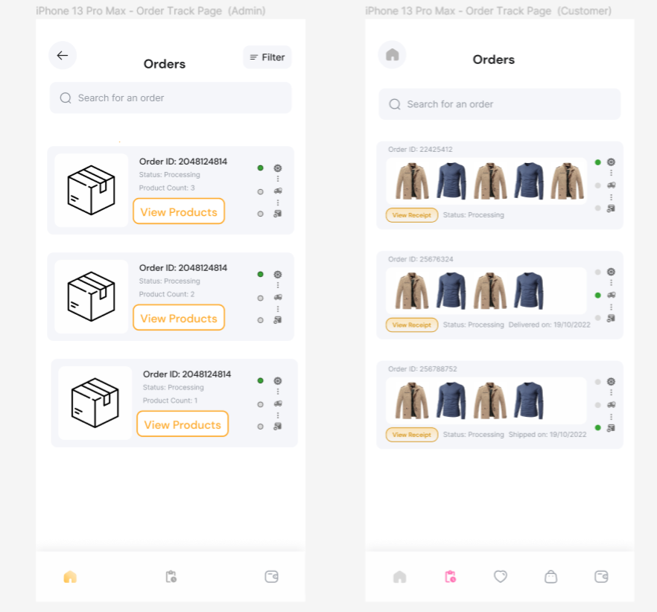

# Final Implemented Design

We had to work with certain limitations of the tools we were using as well as the limited time we could spend on the project. As such, certain features in the design are not functional (only placeholders) in the implementation. Including:

* Sign in with Gmail (in the login screen)
* Dark mode (in the navigation pane)
* Change product image (in the update product screen)
* Category icons are not functional in certain screens due to the difficulty of storing image assets in the database.

Some changes were made to the design of certain screens. For example:

* Add card, add address, and add payment screens were changed to a simple popup due to difficulty of implementing the card design within the limited time of the project.
* Admin reports page was redesigned to better include report information in a concise manner, but there was insufficient time to update the design.

All these changes are minor, and do not affect our project’s fulfillment of the its requirements.

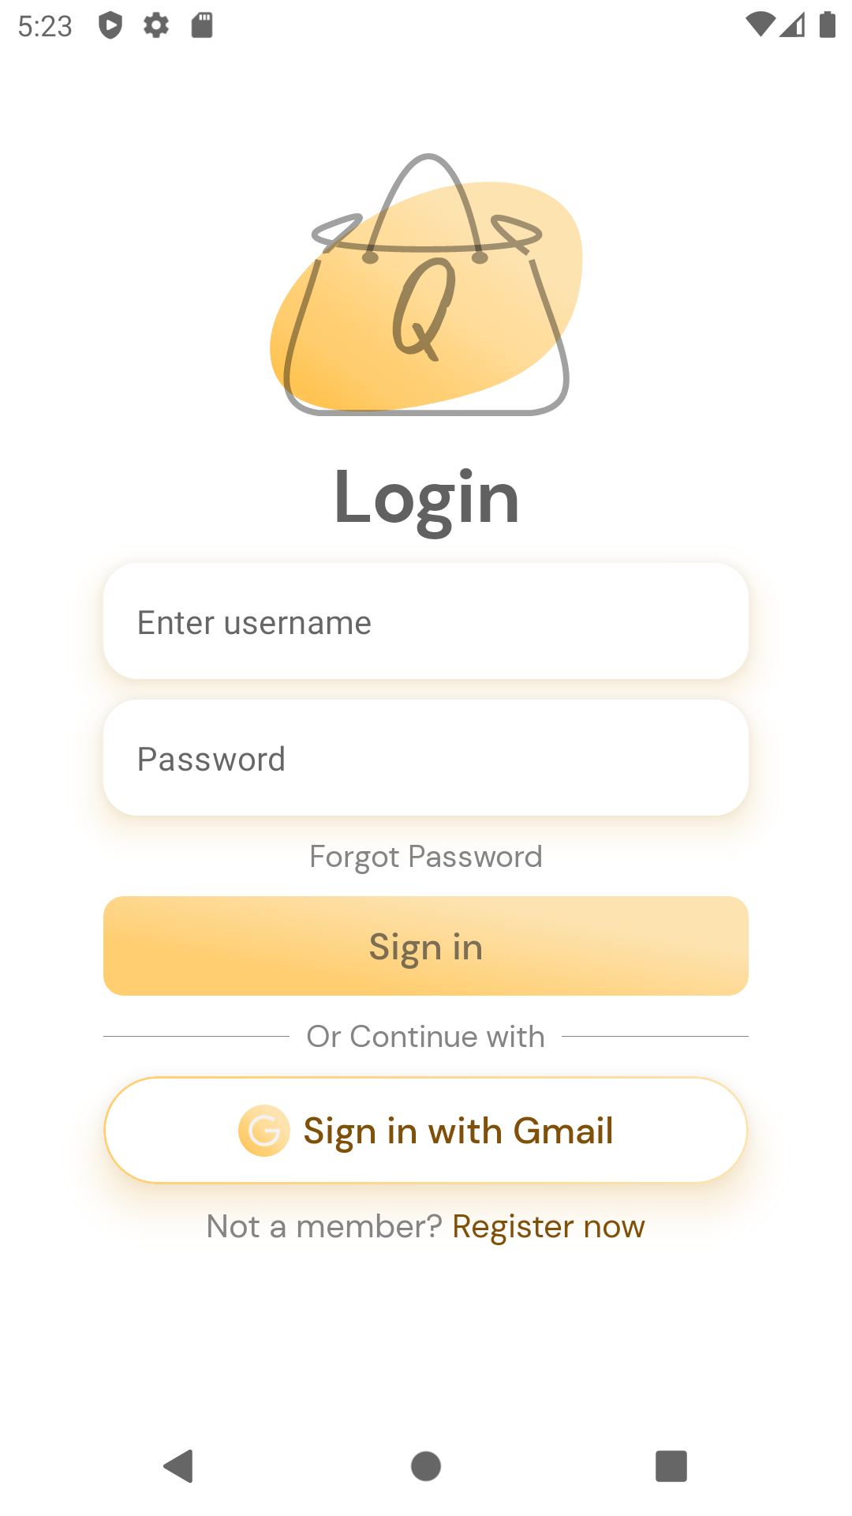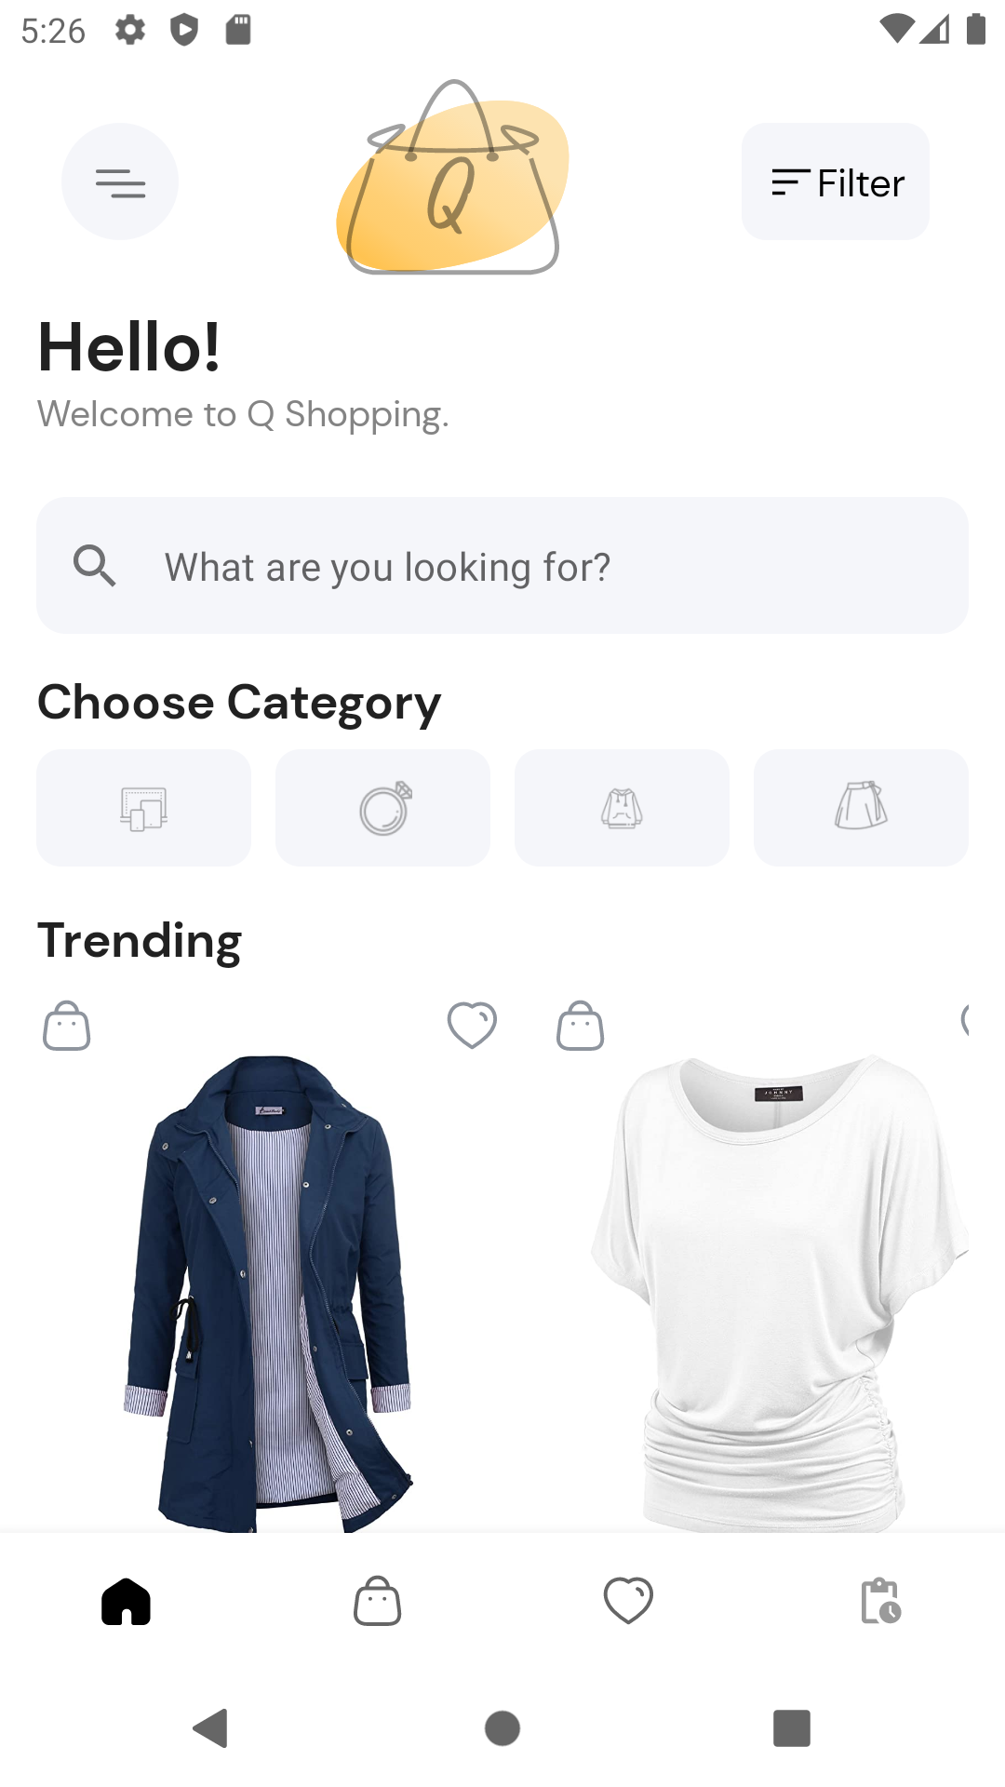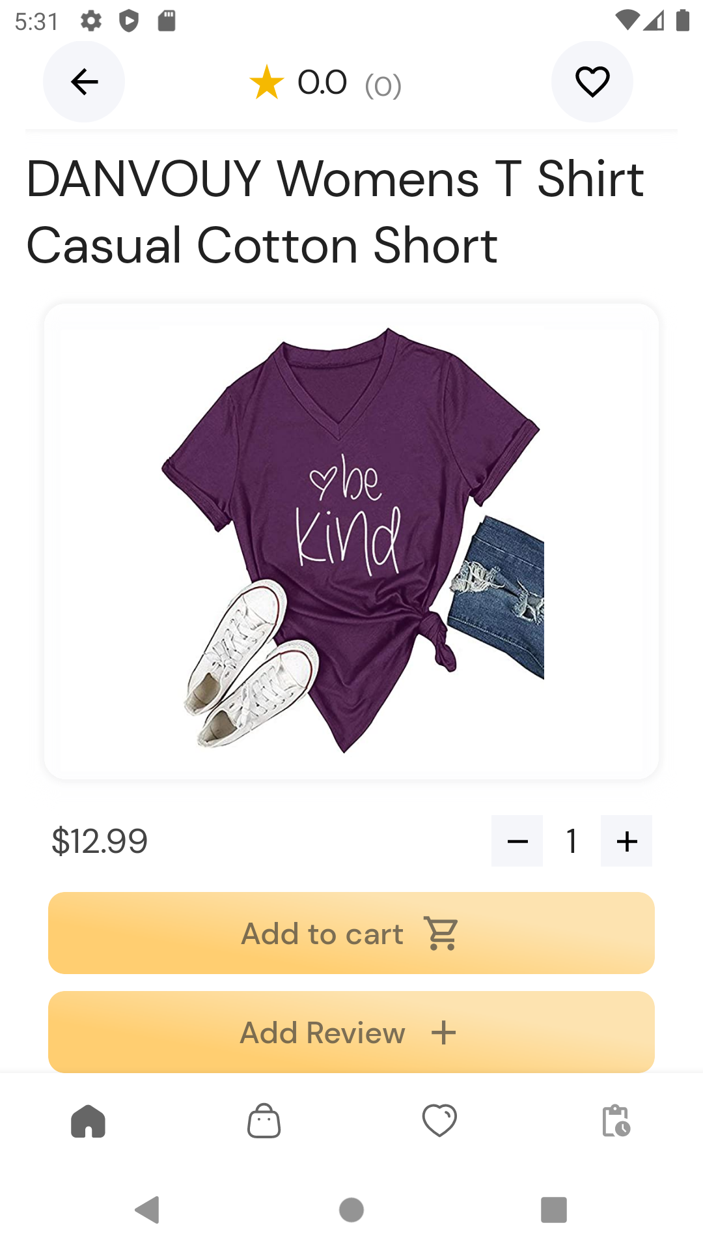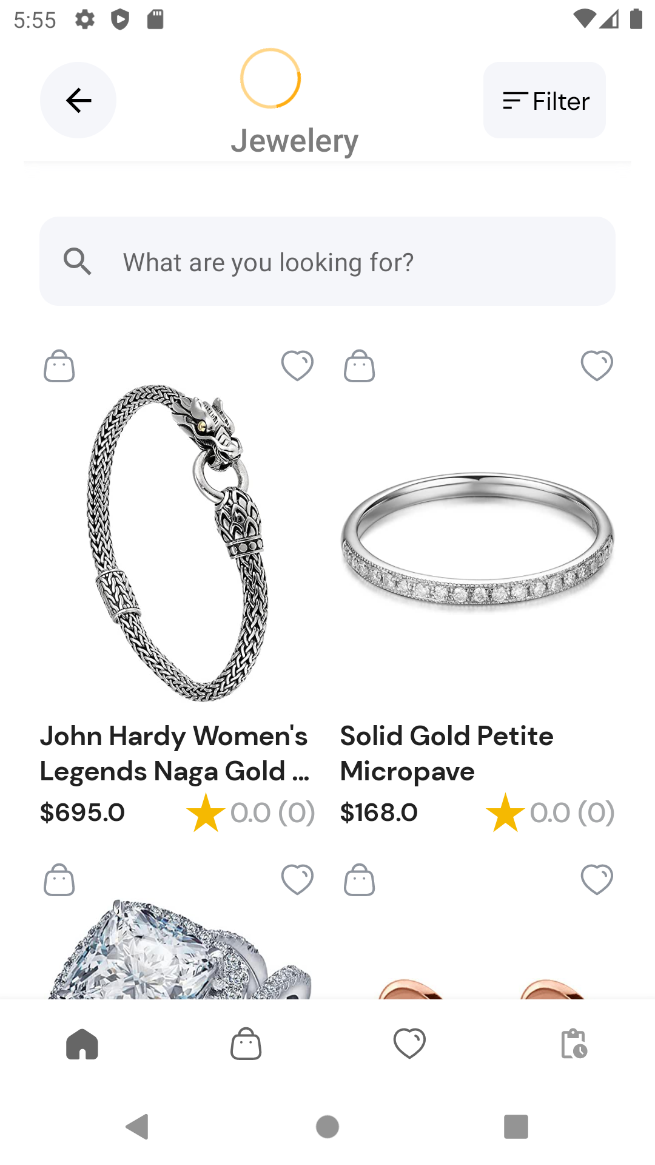

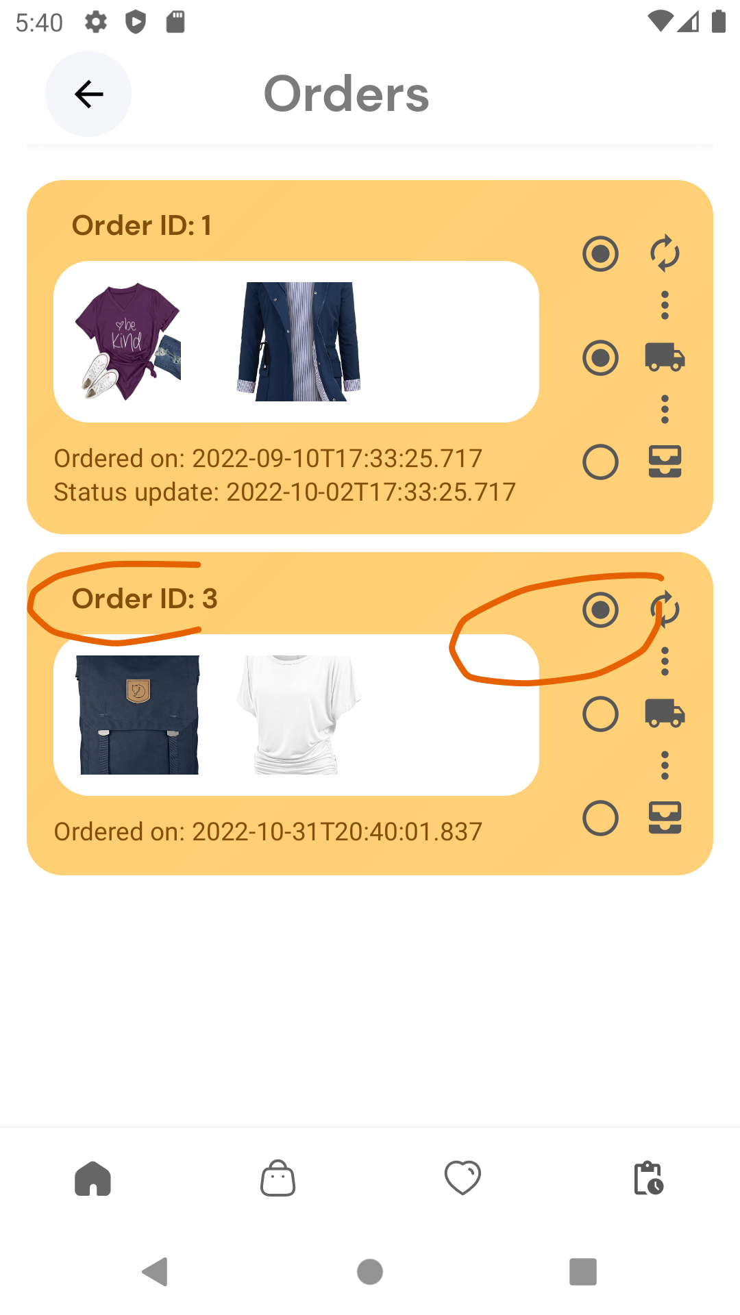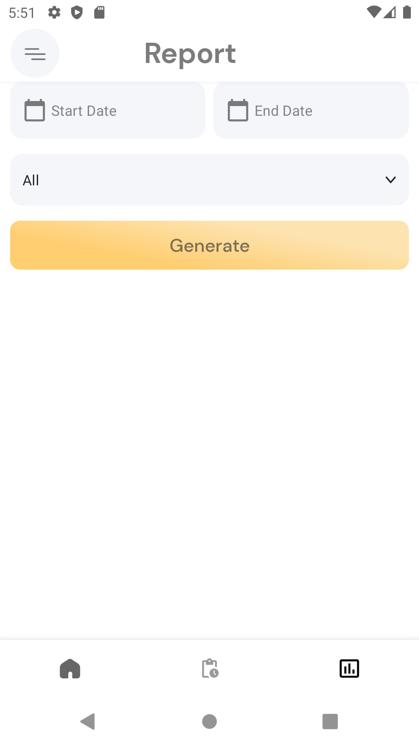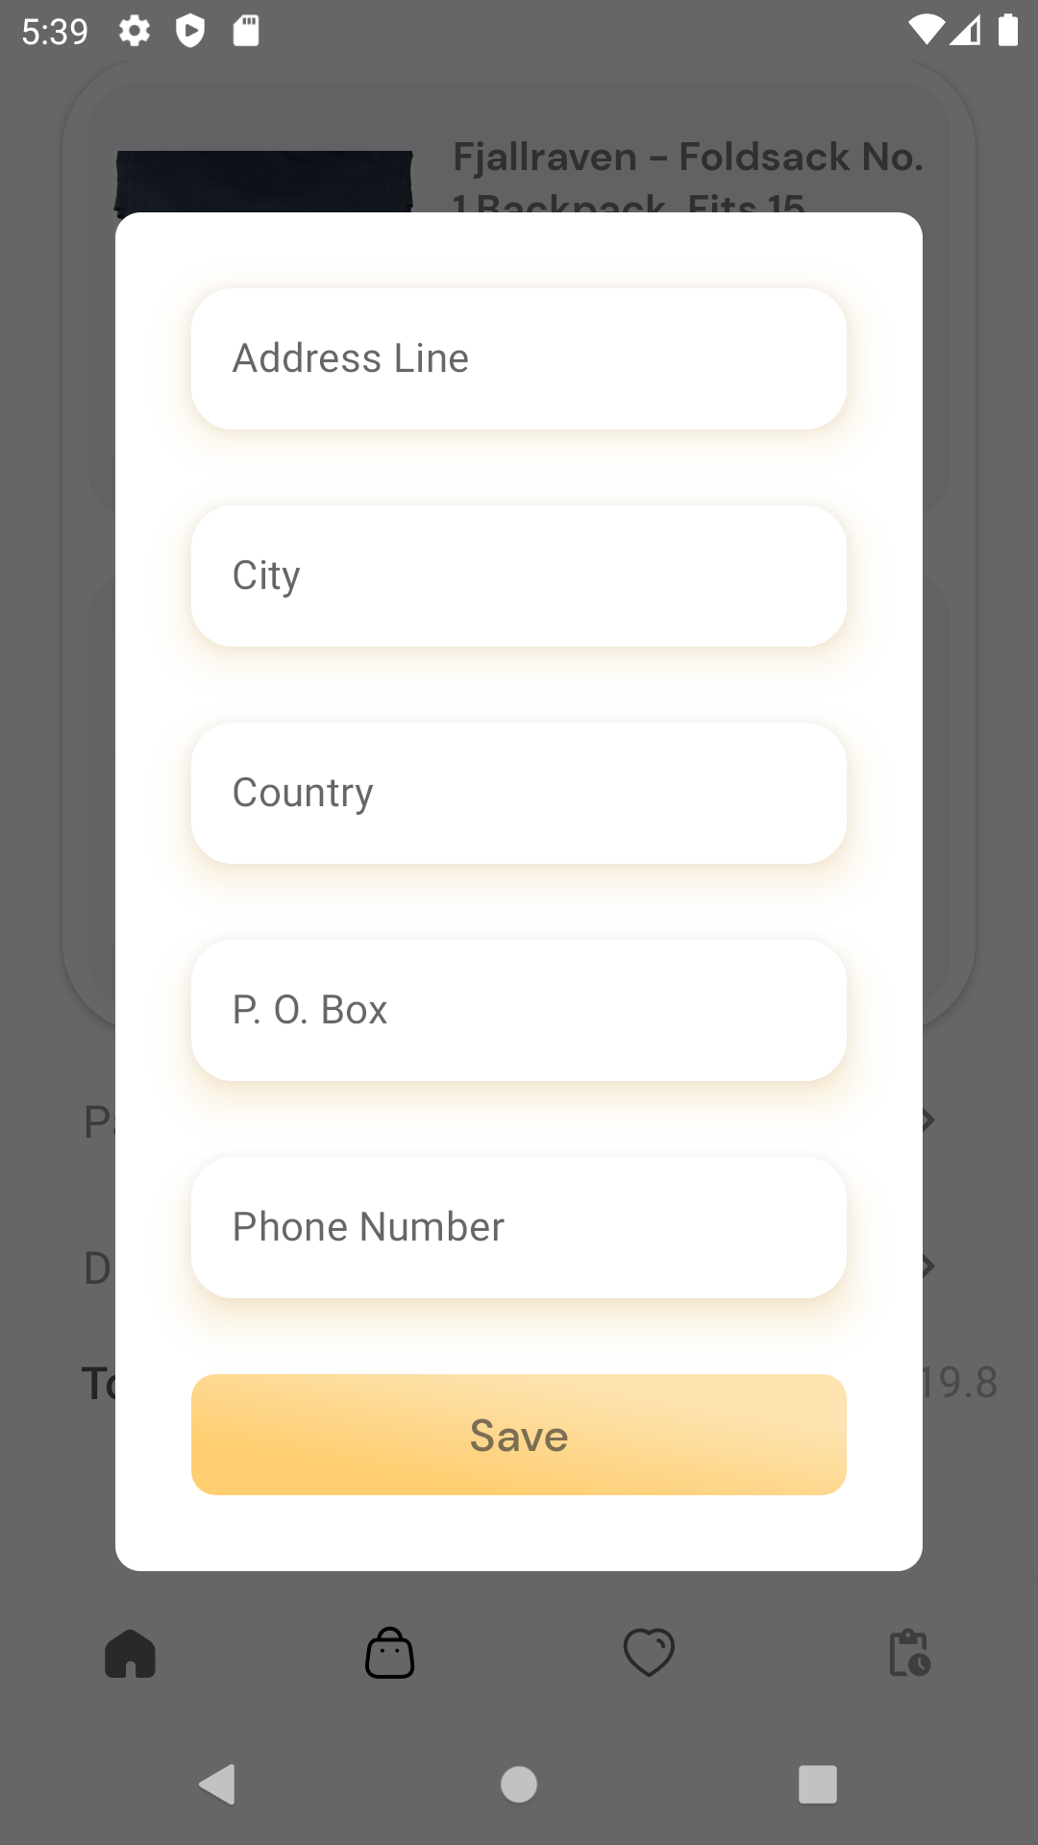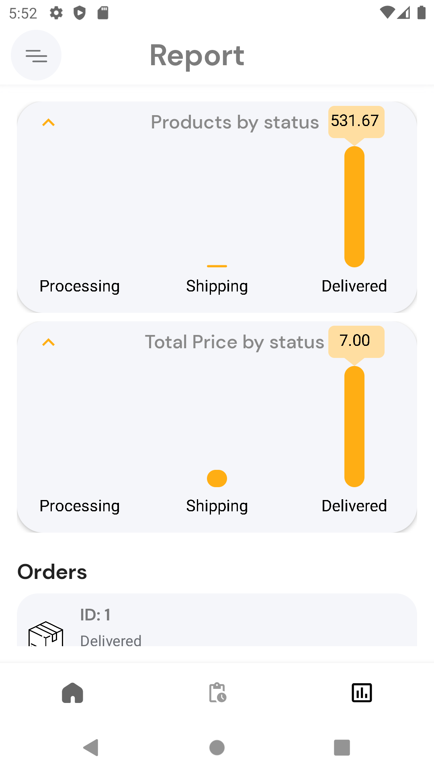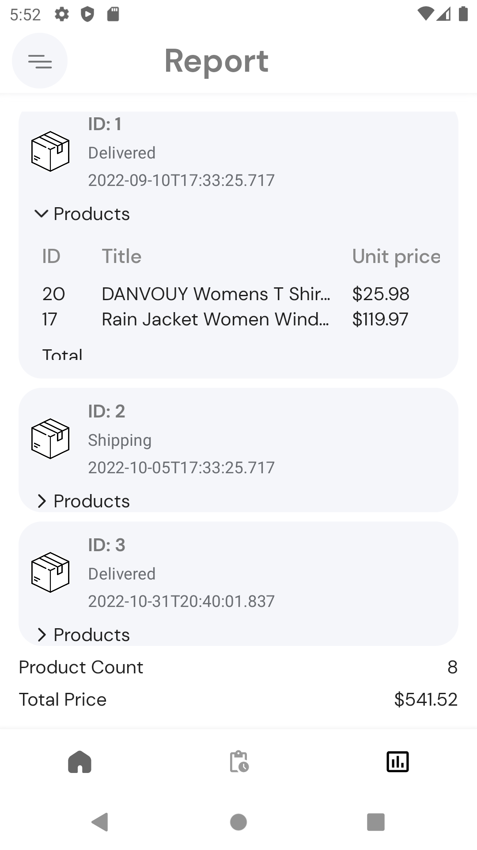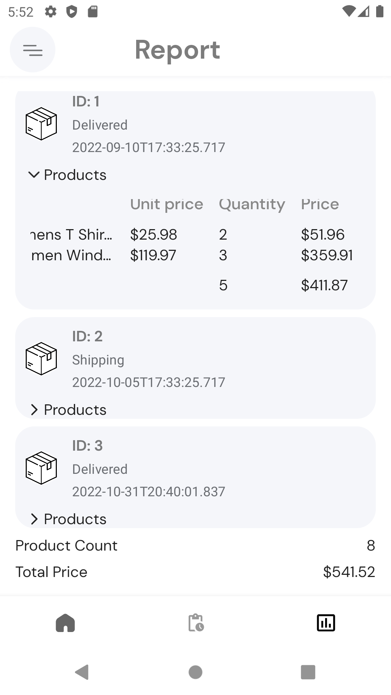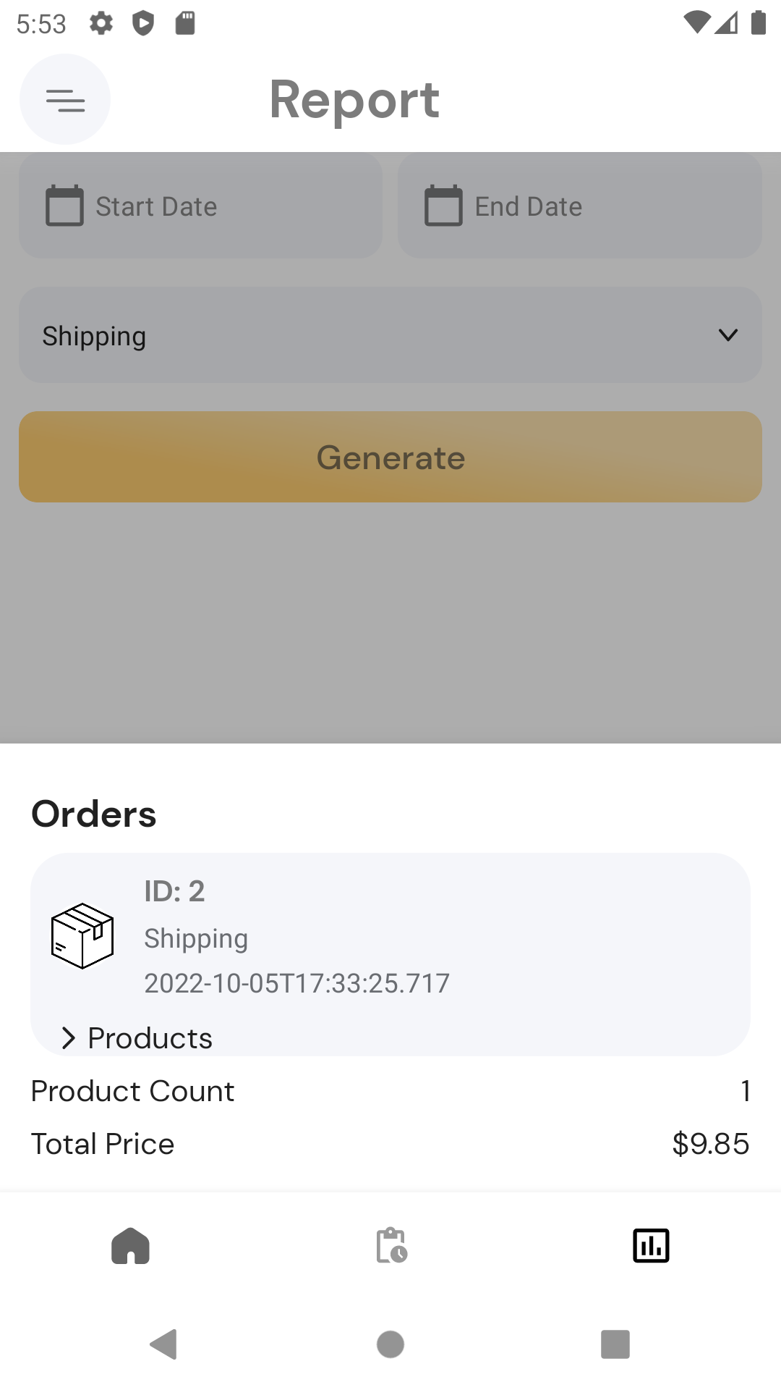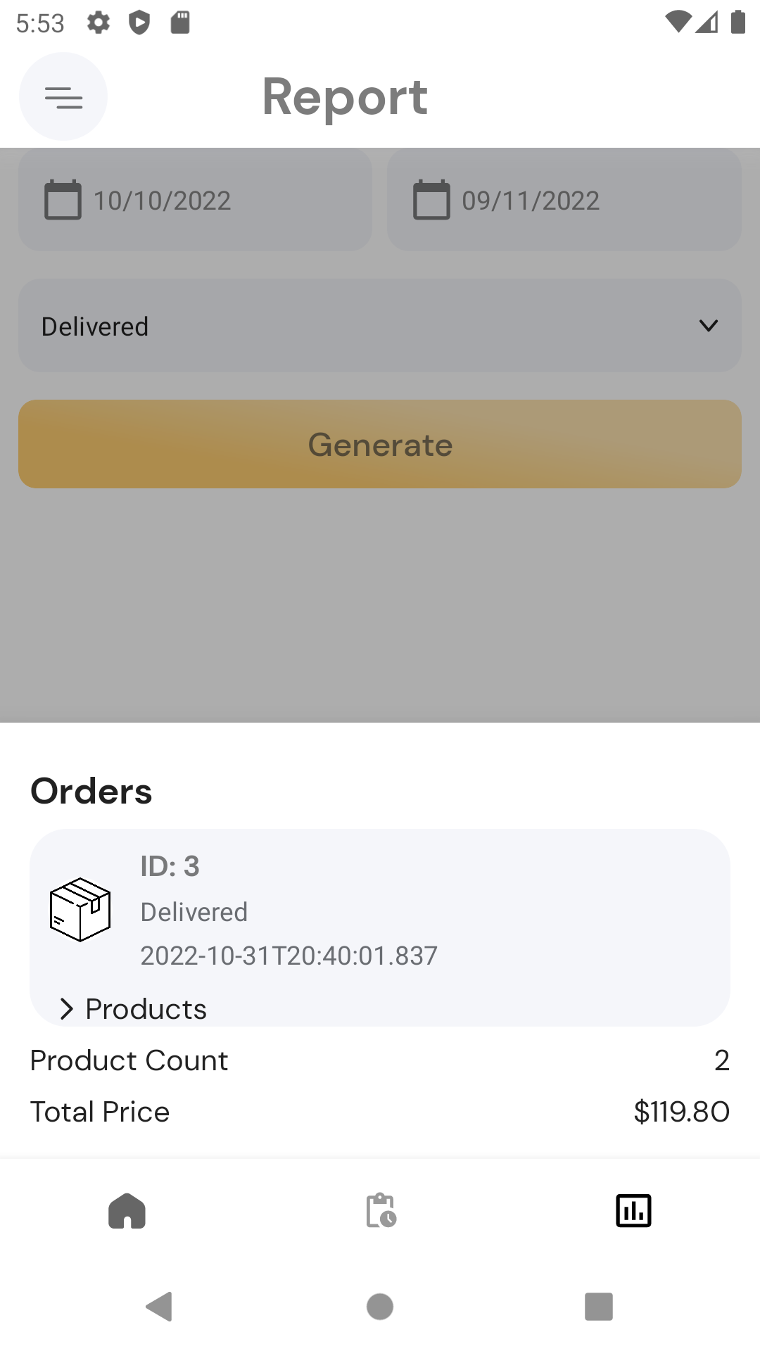

|  |  |
| --- | --- |
| **Screen** | **Composable** |
| Login | LoginScreen()  DividerTextDividerRow()  GradientButton()  ElevatedTextField() |
| RegistrationScreen | RegistrationScreen()  RegistrationHeader()  GradientButton()  MultipleElevatedTextFields() |
| Home | HomeScreen()  MenuButton()  CategoryButton()  ProductCarousel()  FilterPopup()  ProductCard()  FilterButton()  TopNavButton()  SearchBar()  CollapsingHeader()  Section() |
| CategoryScreen | CategoryScreen()  CategoryHeader()  FilterPopup()  ProductCard()  BackButton()  FilterButton()  SearchBar()  Header() |
| CartScreen | CartScreen()  EmptyScreen()  OrderScreenHeader()  CartItemsList()  ItemCard()  OrderFrame()  AddOneMore()  RemoveOneLess()  PaymentFrame()  DeliveryFrame()  OrderSummary()  PlaceOrder()  AddressSettingsDialog()  CardSettingsDialog()  BackButton()  GradientButton()  ElevatedTextField()  Header() |
| WishlistScreen | WishlistScreen()  EmptyWishListScreen()  ProductCard()  BackButton()  Header() |
| AddProduct | AddProductScreen()  ProductForm()  BackButton()  GradientButton()  CustomChoiceBox()  NormalTextField()  QuantitySelector()  Header() |
| AddressScreen | Address()  AddressInfoHeader()  HyperlinkText()  CancelSaveButtonsRow()  MultipleElevatedTextFields() |
| AdminProductDetails | AdminProductDetailScreen()  HeaderXTextField()  ProductImage()  BackButton()  CancelSaveButtonsRow()  Header() |
| AdminReport | AdminReportScreen()  OrdersFilter()  OrderReport()  OrderReportCard()  OrderProductsTable()  BarChart()  Table()  GradientButton()  CustomChoiceBox()  CustomDatePicker()  Header() |
| CardInfo | CardInfoScreen()  CardInfoHeader()  HyperlinkText()  CancelSaveButtonsRow()  MultipleElevatedTextFields() |
| HomeScreenAdmin | HomeScreenAdmin()  ProductCarousel()  ProductAdminCard()  Header()  Section() |
| OrderTrackPageAdmin | ProductListAdmin()  OrderListAdmin()  ProductCardAdmin()  OrderCardAdmin()  OrderTrackPageAdmin()  DeliveryStatus()  BackButton()  FilterButton()  HollowButton()  Header() |
| OrderTrackPageCustomer | ProductListCustomer()  ProductCardCustomer()  OrderListCustomer()  OrderCardCustomer()  OrderTrackPageCustomer()  DeliveryStatus()  BackButton()  Header() |
| ProductDetails | ProductDetailScreen()  ProductReputation()  FavouriteButton()  PriceXQuantity()  Rating()  Review()  AddToCartButton()  AddReviewButton()  DividerTextDividerRow()  ProductImage()  ReviewPopup()  BackButton()  GradientButton()  SmallRectangularButton()  Header() |
| ProfileScreen | ProfileScreen()  ProfileInfoSection()  NonAdminUtils()  AdminUtils()  UserInfoSection()  DataRow()  ProfileImageSection()  ProfileImage()  BackButton()  MatteButton()  Header() |
| UpdateProduct | UpdateProduct()  BackButton()  GradientButton()  Header() |

# Database Design

We used [ERDplus](https://erdplus.com/)[1], and [drawSQL](https://drawsql.app/)[2] to design our database. The conceptual ER diagram was done with ERDplus, but the more detailed schema diagram was done with drawSQL.

We used a local relational database with 8 entities: User, Product, Category, Order, Review, OrderItem, CartItem, WishListItem. The database was interacted with through Android Room, a library for dealing with local SQLite databases in android.

Some notable design decisions:

* We embed user address and payment card details in each order for simplicity.

Datatype Notes:

* Primary keys are auto generated integers.
* Images are stored as URLs to the image resource.
* Dates and times are stored as a Unix timestamp (long)

Schema Diagram:

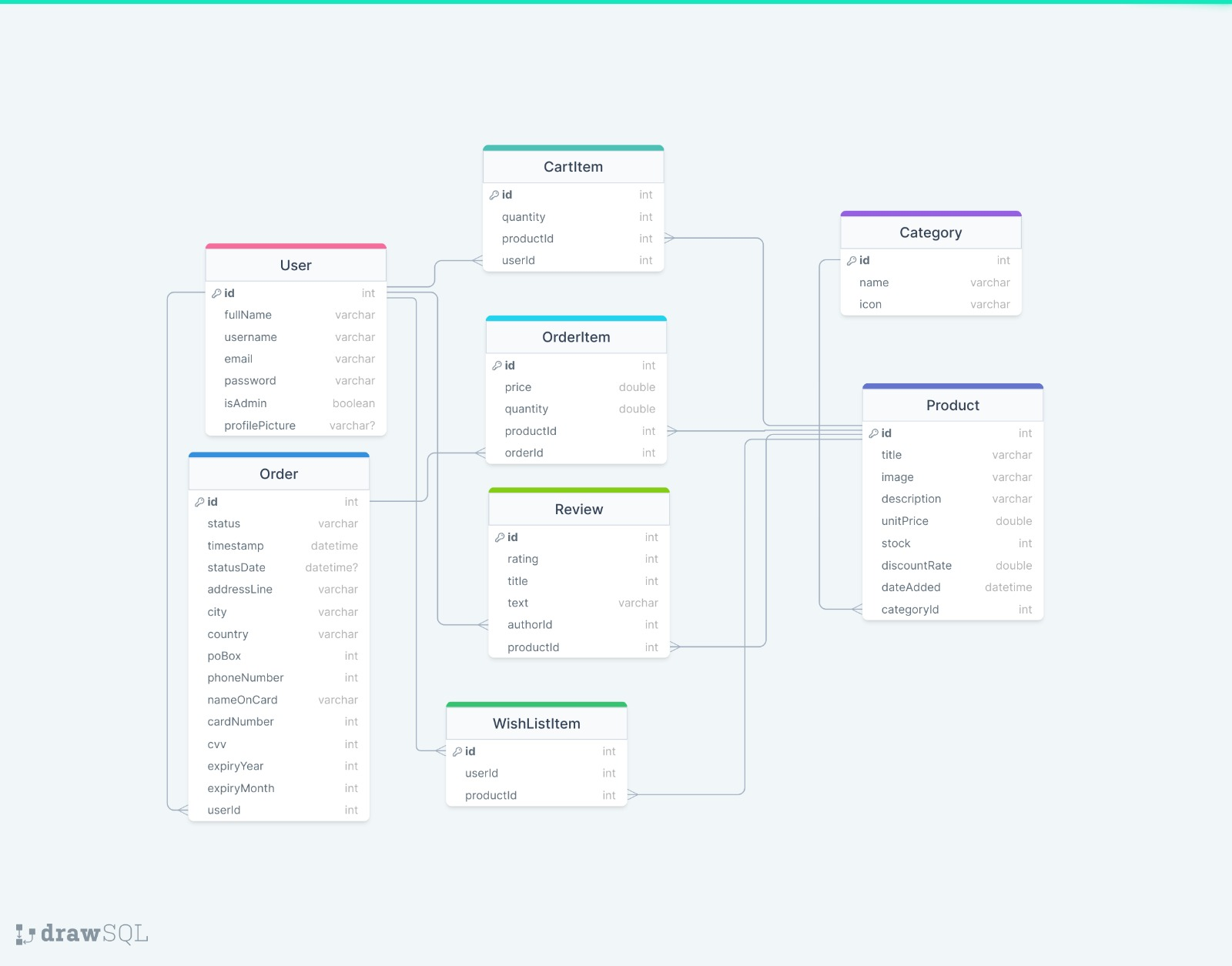

ER diagram:

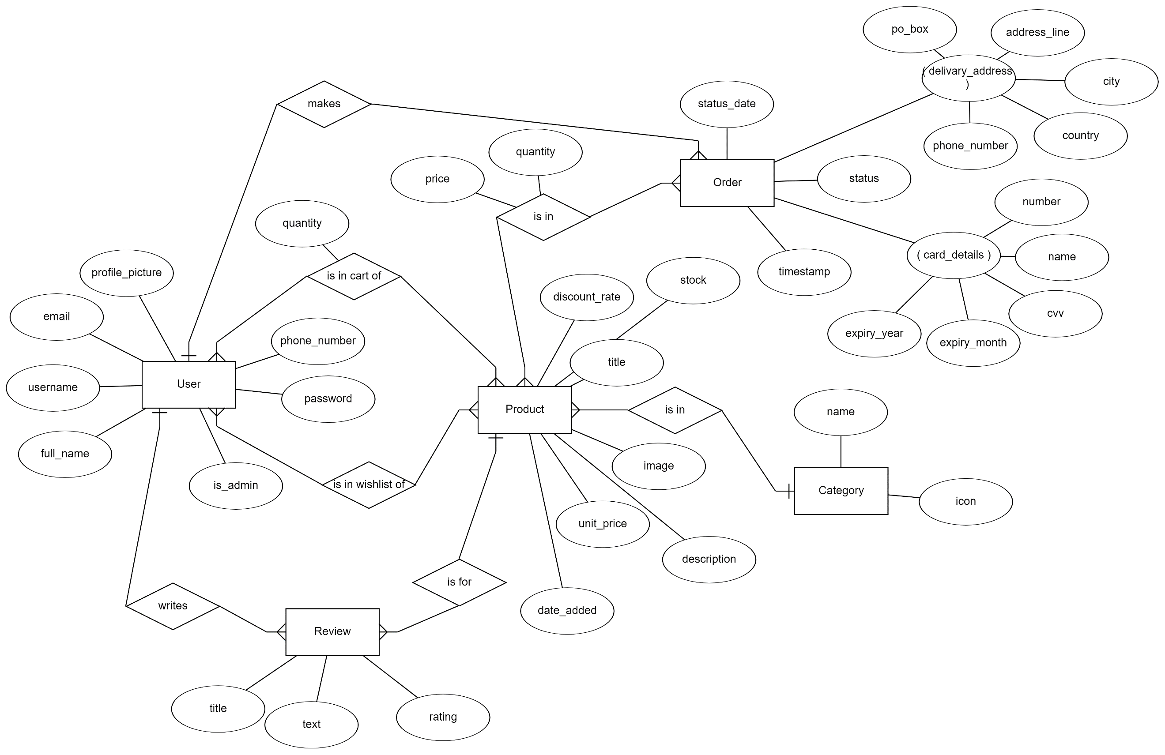

**Phase II**

For phase 2 of the project, we migrated from a local android room database to a cloud database using Firebase’s Firestore database service. The design of the database did not change, only the implementation.

Limitations: Due to the limitations of Firestore, certain queries had to be done outside the database (locally on the device). For example:

* Firestore does not allow joins between collections, or queries from multiple collections. We had to perform multiple queries from different collections and join locally.
* Firestore does not have a string “contains”, query, so the search is implemented by fetching all products and filtering locally

# Design and Architectural Patterns

The architectural pattern we chose for our project is the MVVM architecture.

MVVM illustration

[3]

Our project has directory tree structure that follows mentioned MVVM architecture:

Project Directory Tree

MVVM is a very common architecture for Android applications because it reduces coupling between components, and leads to more robust maintainable code. The project is broken down into:

* Model: The data layer. Made up of repositories that provide an interface for different data sources.
* View: The User Interface layer, made up of composables.
* ViewModel: Connects Model to View by Observing changes to model responding to events in view.

We always favored a layered architecture, and chose MVVM because it fits android applications, and is well-supported by official and third-party libraries.

In phase 1, we used a local android room database as our data store and the initial data was local json files. In phase 2 we used a Firestroe cloud database as our data store. Our initial data is hosted on GitHub pages in the form of JSON files. When initializing, we making API calls to GitHub pages using Retrofit to fetch the data in order to populate the Firestore database.

The base URL for the initialization data is

https://gist.githubusercontent.com/Ahmed-Abdou14/0794ba99306180246df44cb059c183d4/raw/7b3099fecfa457fc8f75800ca057aa834a45c072/

The following is a list of endpoints for initialization files:

|  |  |
| --- | --- |
| Endpoint | File |
| /users | JSON list of initial users |
| /categories | JSON list of initial product categories |
| /products2 | JSON list of initial products |
| /orders | JSON list of initial orders |
| /orderItems | JSON list of initial order items |
| /cartItems | JSON list of initial cart items |
| /reviews | JSON list of initial reviews |

# Implementation

Implementation decisions that affected our project:

* We used Jetpack compose, android room, Firebase, Retrofit, and a number of UI libraries.
* Globals object (which includes the database and currently logged in user) is injected in the application onCreate().
* ViewModels use Flows to deliver live data (List<Product>, List<Order> etc.)
* Android room @emebeded entities are used to include related data in a query. For example ProductWithData includes product, all its reviews, its review score, whether or not it’s in cart and whether or not it’s in wish list. This is all queried in mapped by android room.

**Class diagram (phase 1):**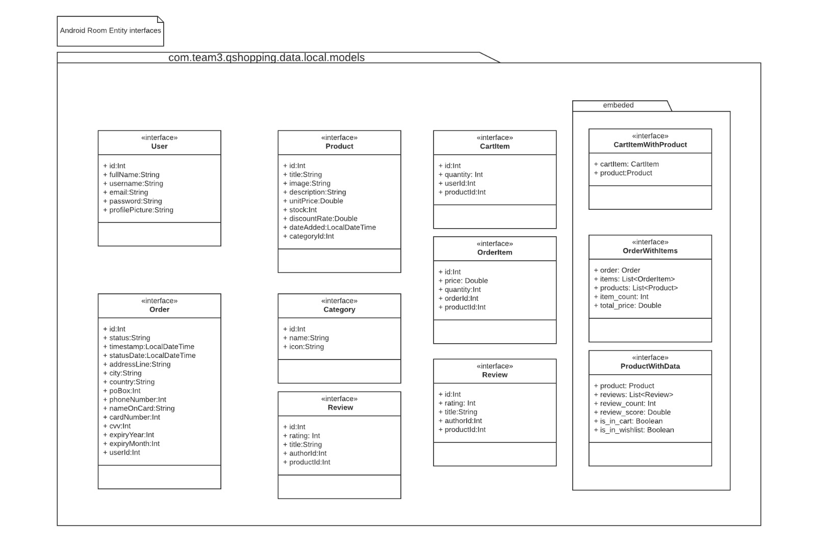

[4]

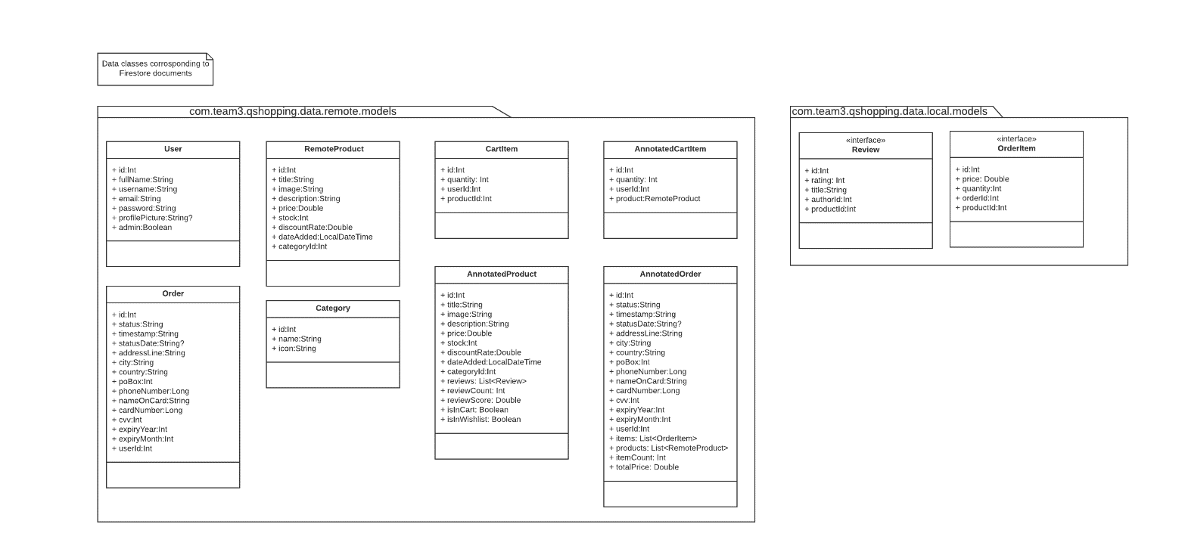**Class diagram (phase 2):**

**Demo:**

1. Register

|  |  |  |  |
| --- | --- | --- | --- |
|  |  |  |  |

1. Login

|  |  |
| --- | --- |
|  |  |

1. View Product

|  |  |  |  |
| --- | --- | --- | --- |
|  |  |  |  |
|  |  |  |  |
|  |  |  |  |
|  |  |  |  |

|  |
| --- |
|  |

1. Cart

|  |  |  |
| --- | --- | --- |
|  |  |  |

1. Place Order

|  |  |  |  |
| --- | --- | --- | --- |
|  |  |  |  |
|  |  |  |  |

1. Post Review

|  |  |  |  |
| --- | --- | --- | --- |
|  |  |  |  |
|  |  |  |  |

1. Track Order

|  |
| --- |
|  |

1. Admin Dashboard

|  |  |  |  |
| --- | --- | --- | --- |
|  |  |  |  |
|  |  |  |  |

1. Admin Reports

|  |  |  |  |
| --- | --- | --- | --- |
|  |  |  |  |
|  |  |  |  |

# Additional Features

The following additional features were added:

Wishlist: user is able to save products to a wish list. They can then see all products in their wish list in the wish list screen.

On the home screen we group products into on sale, new additions and trending. On sale shows products with a discount rate > 0, Trending shows top 50 most ordered products, and new additions shows products that were added in the last year.

# New Gained Knowledge and Skills

We learned mainly by going through tutorials and documentations online. The provided playlists were very helpful as they covered basically everything that was needed in the project and more. For learning new language, Kotlin, documentation alone was helpful to at least cover the main ideas and get started with the project. Many concepts were learned as we moved on.

New skills:

* Android mobile development with Kotlin and Jetpack Compose.
* Familiarity with MVVM architecture.
* Using android room.
* Kotlin coroutines and flows
* Dealing with the concept of composables, and how to break down an app into reusable UI parts.

Improved skills:

* UI design
* Database design
* How to use version control systems: git, and github
* Working in a team, time management, social skills

# Reflections

Working with GitHub in itself was a challenge faced which was overcome by fellow group members who had prior knowledge of using different features such as branching and resolving conflicts while merging. Proper architecture was followed as suggested in the labs as the project started to grow and number of files kept increasing. Many errors faced on android studio were due to gradle build, so we learned that before looking through or resolving any error, have the gradle synced and see if the errors got fixed or reinstalling the app on emulator or phone and building it again.

Sometimes progress was slow on the project due to it not being clear what each person was working on and how to start with certain areas.

From next time we would focus more on the important parts first and develop from there, instead of sometimes getting stuck on lesser important issues that we faced.

# Resources

[1] ERDPlus https://erdplus.com/

[2] Draw SQL https://drawsql.app/

[3] Lucid Charts

[4] <https://blog.mindorks.com/mvvm-architecture-android-tutorial-for-beginners-step-by-step-guide>

# Appendix A: Json Files

**Users**

[

{

"id": 1,

"fullName": "Mister Admin",

"userName": "admin",

"email": "admin@admin.com",

"password": "admin123",

"isAdmin": true

},

{

"id": 2,

"fullName": "Ahmad Ahmad",

"userName": "ahmadlol",

"email": "ahmad@ahmad.com",

"password": "ahmad123",

"isAdmin": false

},

{

"id": 3,

"fullName": "Ali Ali",

"userName": "lolali",

"email": "ali@ali.com",

"password": "ali123",

"isAdmin": false

}

]

**Categories**

[

{

"id": 1,

"name": "Electronics",

"icon": ""

},

{

"id": 2,

"name": "Jewelery",

"icon": ""

},

{

"id": 3,

"name": "Men's Clothing",

"icon": ""

},

{

"id": 4,

"name": "Women's Clothing",

"icon": ""

}

]

**Products**

[

{

"id": 1,

"title": "Fjallraven - Foldsack No. 1 Backpack, Fits 15 Laptops",

"price": 109.95,

"description": "Your perfect pack for everyday use and walks in the forest. Stash your laptop (up to 15 inches) in the padded sleeve, your everyday",

"categoryId": 3,

"image": "https://fakestoreapi.com/img/81fPKd-2AYL._AC_SL1500_.jpg",

"dateAdded": "2012-09-23T20:59:02",

"discountRate": 0.17,

"stock": 343

},

{

"id": 2,

"title": "Mens Casual Premium Slim Fit T-Shirts ",

"price": 22.3,

"description": "Slim-fitting style, contrast raglan long sleeve, three-button henley placket, light weight & soft fabric for breathable and comfortable wearing. And Solid stitched shirts with round neck made for durability and a great fit for casual fashion wear and diehard baseball fans. The Henley style round neckline includes a three-button placket.",

"categoryId": 3,

"image": "https://fakestoreapi.com/img/71-3HjGNDUL._AC_SY879._SX._UX._SY._UY_.jpg",

"dateAdded": "2000-11-21T15:34:50",

"discountRate": 0.33,

"stock": 751

},

{

"id": 3,

"title": "Mens Cotton Jacket",

"price": 55.99,

"description": "great outerwear jackets for Spring/Autumn/Winter, suitable for many occasions, such as working, hiking, camping, mountain/rock climbing, cycling, traveling or other outdoors. Good gift choice for you or your family member. A warm hearted love to Father, husband or son in this thanksgiving or Christmas Day.",

"categoryId": 3,

"image": "https://fakestoreapi.com/img/71li-ujtlUL._AC_UX679_.jpg",

"dateAdded": "2020-07-26T22:03:15",

"discountRate": 0.50,

"stock": 507

},

{

"id": 4,

"title": "Mens Casual Slim Fit",

"price": 15.99,

"description": "The color could be slightly different between on the screen and in practice. / Please note that body builds vary by person, therefore, detailed size information should be reviewed below on the product description.",

"categoryId": 3,

"image": "https://fakestoreapi.com/img/71YXzeOuslL._AC_UY879_.jpg",

"dateAdded": "2017-08-18T13:09:20",

"stock": 440

},

{

"id": 5,

"title": "John Hardy Women's Legends Naga Gold & Silver Dragon Station Chain Bracelet",

"price": 695,

"description": "From our Legends Collection, the Naga was inspired by the mythical water dragon that protects the ocean's pearl. Wear facing inward to be bestowed with love and abundance, or outward for protection.",

"categoryId": 2,

"image": "https://fakestoreapi.com/img/71pWzhdJNwL._AC_UL640_QL65_ML3_.jpg",

"dateAdded": "2001-09-19T19:55:07",

"stock": 591

},

{

"id": 6,

"title": "Solid Gold Petite Micropave ",

"price": 168,

"description": "Satisfaction Guaranteed. Return or exchange any order within 30 days.Designed and sold by Hafeez Center in the United States. Satisfaction Guaranteed. Return or exchange any order within 30 days.",

"categoryId": 2,

"image": "https://fakestoreapi.com/img/61sbMiUnoGL._AC_UL640_QL65_ML3_.jpg",

"dateAdded": "2008-08-29T07:39:13",

"stock": 176

},

{

"id": 7,

"title": "White Gold Plated Princess",

"price": 9.99,

"description": "Classic Created Wedding Engagement Solitaire Diamond Promise Ring for Her. Gifts to spoil your love more for Engagement, Wedding, Anniversary, Valentine's Day...",

"categoryId": 2,

"image": "https://fakestoreapi.com/img/71YAIFU48IL._AC_UL640_QL65_ML3_.jpg",

"dateAdded": "2018-12-17T09:16:57",

"stock": 820

},

{

"id": 8,

"title": "Pierced Owl Rose Gold Plated Stainless Steel Double",

"price": 10.99,

"description": "Rose Gold Plated Double Flared Tunnel Plug Earrings. Made of 316L Stainless Steel",

"categoryId": 2,

"image": "https://fakestoreapi.com/img/51UDEzMJVpL._AC_UL640_QL65_ML3_.jpg",

"dateAdded": "2015-11-08T12:29:21",

"stock": 420

},

{

"id": 9,

"title": "WD 2TB Elements Portable External Hard Drive - USB 3.0 ",

"price": 64,

"description": "USB 3.0 and USB 2.0 Compatibility Fast data transfers Improve PC Performance High Capacity; Compatibility Formatted NTFS for Windows 10, Windows 8.1, Windows 7; Reformatting may be required for other operating systems; Compatibility may vary depending on user’s hardware configuration and operating system",

"categoryId": 1,

"image": "https://fakestoreapi.com/img/61IBBVJvSDL._AC_SY879_.jpg",

"dateAdded": "2013-10-18T03:30:45",

"stock": 321

},

{

"id": 10,

"title": "SanDisk SSD PLUS 1TB Internal SSD - SATA III 6 Gb/s",

"price": 109,

"description": "Easy upgrade for faster boot up, shutdown, application load and response (As compared to 5400 RPM SATA 2.5” hard drive; Based on published specifications and internal benchmarking tests using PCMark vantage scores) Boosts burst write performance, making it ideal for typical PC workloads The perfect balance of performance and reliability Read/write speeds of up to 535MB/s/450MB/s (Based on internal testing; Performance may vary depending upon drive capacity, host device, OS and application.)",

"categoryId": 1,

"image": "https://fakestoreapi.com/img/61U7T1koQqL._AC_SX679_.jpg",

"dateAdded": "2014-09-07T13:45:00",

"stock": 266

},

{

"id": 11,

"title": "Silicon Power 256GB SSD 3D NAND A55 SLC Cache Performance Boost SATA III 2.5",

"price": 109,

"description": "3D NAND flash are applied to deliver high transfer speeds Remarkable transfer speeds that enable faster bootup and improved overall system performance. The advanced SLC Cache Technology allows performance boost and longer lifespan 7mm slim design suitable for Ultrabooks and Ultra-slim notebooks. Supports TRIM command, Garbage Collection technology, RAID, and ECC (Error Checking & Correction) to provide the optimized performance and enhanced reliability.",

"categoryId": 1,

"image": "https://fakestoreapi.com/img/71kWymZ+c+L._AC_SX679_.jpg",

"dateAdded": "2006-11-19T18:23:08",

"stock": 616

},

{

"id": 12,

"title": "WD 4TB Gaming Drive Works with Playstation 4 Portable External Hard Drive",

"price": 114,

"description": "Expand your PS4 gaming experience, Play anywhere Fast and easy, setup Sleek design with high capacity, 3-year manufacturer's limited warranty",

"categoryId": 1,

"image": "https://fakestoreapi.com/img/61mtL65D4cL._AC_SX679_.jpg",

"dateAdded": "2002-07-28T19:31:06",

"stock": 748

},

{

"id": 13,

"title": "Acer SB220Q bi 21.5 inches Full HD (1920 x 1080) IPS Ultra-Thin",

"price": 599,

"description": "21. 5 inches Full HD (1920 x 1080) widescreen IPS display And Radeon free Sync technology. No compatibility for VESA Mount Refresh Rate: 75Hz - Using HDMI port Zero-frame design | ultra-thin | 4ms response time | IPS panel Aspect ratio - 16: 9. Color Supported - 16. 7 million colors. Brightness - 250 nit Tilt angle -5 degree to 15 degree. Horizontal viewing angle-178 degree. Vertical viewing angle-178 degree 75 hertz",

"categoryId": 1,

"image": "https://fakestoreapi.com/img/81QpkIctqPL._AC_SX679_.jpg",

"dateAdded": "2015-06-12T07:34:00",

"stock": 311

},

{

"id": 14,

"title": "Samsung 49-Inch CHG90 144Hz Curved Gaming Monitor (LC49HG90DMNXZA) – Super Ultrawide Screen QLED ",

"price": 999.99,

"description": "49 INCH SUPER ULTRAWIDE 32:9 CURVED GAMING MONITOR with dual 27 inch screen side by side QUANTUM DOT (QLED) TECHNOLOGY, HDR support and factory calibration provides stunningly realistic and accurate color and contrast 144HZ HIGH REFRESH RATE and 1ms ultra fast response time work to eliminate motion blur, ghosting, and reduce input lag",

"categoryId": 1,

"image": "https://fakestoreapi.com/img/81Zt42ioCgL._AC_SX679_.jpg",

"dateAdded": "2020-05-19T12:47:30",

"stock": 287

},

{

"id": 15,

"title": "BIYLACLESEN Women's 3-in-1 Snowboard Jacket Winter Coats",

"price": 56.99,

"description": "Note:The Jackets is US standard size, Please choose size as your usual wear Material: 100% Polyester; Detachable Liner Fabric: Warm Fleece. Detachable Functional Liner: Skin Friendly, Lightweigt and Warm.Stand Collar Liner jacket, keep you warm in cold weather. Zippered Pockets: 2 Zippered Hand Pockets, 2 Zippered Pockets on Chest (enough to keep cards or keys)and 1 Hidden Pocket Inside.Zippered Hand Pockets and Hidden Pocket keep your things secure. Humanized Design: Adjustable and Detachable Hood and Adjustable cuff to prevent the wind and water,for a comfortable fit. 3 in 1 Detachable Design provide more convenience, you can separate the coat and inner as needed, or wear it together. It is suitable for different season and help you adapt to different climates",

"categoryId": 4,

"image": "https://fakestoreapi.com/img/51Y5NI-I5jL._AC_UX679_.jpg",

"dateAdded": "2021-11-08T07:25:40",

"stock": 97

},

{

"id": 16,

"title": "Lock and Love Women's Removable Hooded Faux Leather Moto Biker Jacket",

"price": 29.95,

"description": "100% POLYURETHANE(shell) 100% POLYESTER(lining) 75% POLYESTER 25% COTTON (SWEATER), Faux leather material for style and comfort / 2 pockets of front, 2-For-One Hooded denim style faux leather jacket, Button detail on waist / Detail stitching at sides, HAND WASH ONLY / DO NOT BLEACH / LINE DRY / DO NOT IRON",

"categoryId": 4,

"image": "https://fakestoreapi.com/img/81XH0e8fefL._AC_UY879_.jpg",

"dateAdded": "2005-08-11T12:33:26",

"stock": 923

},

{

"id": 17,

"title": "Rain Jacket Women Windbreaker Striped Climbing Raincoats",

"price": 39.99,

"description": "Lightweight perfet for trip or casual wear---Long sleeve with hooded, adjustable drawstring waist design. Button and zipper front closure raincoat, fully stripes Lined and The Raincoat has 2 side pockets are a good size to hold all kinds of things, it covers the hips, and the hood is generous but doesn't overdo it.Attached Cotton Lined Hood with Adjustable Drawstrings give it a real styled look.",

"categoryId": 4,

"image": "https://fakestoreapi.com/img/71HblAHs5xL._AC_UY879_-2.jpg",

"dateAdded": "2006-07-03T14:43:25",

"stock": 740

},

{

"id": 18,

"title": "MBJ Women's Solid Short Sleeve Boat Neck V ",

"price": 9.85,

"description": "95% RAYON 5% SPANDEX, Made in USA or Imported, Do Not Bleach, Lightweight fabric with great stretch for comfort, Ribbed on sleeves and neckline / Double stitching on bottom hem",

"categoryId": 4,

"image": "https://fakestoreapi.com/img/71z3kpMAYsL._AC_UY879_.jpg",

"dateAdded": "2007-12-07T07:27:12",

"stock": 680

},

{

"id": 19,

"title": "Opna Women's Short Sleeve Moisture",

"price": 7.95,

"description": "100% Polyester, Machine wash, 100% cationic polyester interlock, Machine Wash & Pre Shrunk for a Great Fit, Lightweight, roomy and highly breathable with moisture wicking fabric which helps to keep moisture away, Soft Lightweight Fabric with comfortable V-neck collar and a slimmer fit, delivers a sleek, more feminine silhouette and Added Comfort",

"categoryId": 4,

"image": "https://fakestoreapi.com/img/51eg55uWmdL._AC_UX679_.jpg",

"dateAdded": "2016-02-02T09:27:26",

"stock": 644

},

{

"id": 20,

"title": "DANVOUY Womens T Shirt Casual Cotton Short",

"price": 12.99,

"description": "95%Cotton,5%Spandex, Features: Casual, Short Sleeve, Letter Print,V-Neck,Fashion Tees, The fabric is soft and has some stretch., Occasion: Casual/Office/Beach/School/Home/Street. Season: Spring,Summer,Autumn,Winter.",

"categoryId": 4,

"image": "https://fakestoreapi.com/img/61pHAEJ4NML._AC_UX679_.jpg",

"dateAdded": "2019-10-22T15:07:09",

"stock": 985

}

]

**Orders**

[

{

"id": 1,

"status": "Shipping",

"timestamp": "2022-09-10T14:33:25.717",

"statusDate": "2022-10-02T14:33:25.717",

"userId": 2,

"addressLine": "72, That Street",

"city": "Doha",

"country": "Qatar",

"poBox": 2713,

"phoneNumber": 12345678,

"nameOnCard": "Ahmad Ahmad",

"cardNumber": 1234567890123456,

"cvv": 123,

"expiryYear": 2024,

"expiryMonth": 12

},

{

"id": 2,

"status": "Processing",

"timestamp": "2022-10-05T14:33:25.717",

"statusDate": "2022-10-05T14:33:25.717",

"userId": 3,

"addressLine": "27, This Street",

"city": "Doha",

"country": "Qatar",

"poBox": 2713,

"phoneNumber": 87654321,

"nameOnCard": "Ali Ali",

"cardNumber": 6543210987654321,

"cvv": 321,

"expiryYear": 2024,

"expiryMonth": 12

}

]

**Order Items**

[

{

"id": 3,

"price": 9.85,

"quantity": 1,

"productId": 18,

"orderId": 2

},

{

"id": 4,

"price": 25.98,

"quantity": 2,

"productId": 20,

"orderId": 1

},

{

"id": 5,

"price": 119.97,

"quantity": 3,

"productId": 17,

"orderId": 1

}

]

**Cart Items**

[

{

"id": 1,

"quantity": 2,

"userId": 2,

"productId": 5

},

{

"id": 2,

"quantity": 4,

"userId": 2,

"productId": 6

}

]

**Reviews**

[

{

"id": 1,

"rating": 3,

"title": "Was nice enough",

"text": "It was nice enough",

"authorId": 2,

"productId": 1

},

{

"id": 3,

"rating": 2,

"title": "Bad",

"text": "It was bad",

"authorId": 3,

"productId": 2

},

{

"id": 2,

"rating": 4,

"title": "Very good",

"text": "It was very nice",

"authorId": 2,

"productId": 2

}

]